Introduction of Process Synchronization
- Process Synchronization is a technique which is used to coordinate the process that use shared Data

On the basis of synchronization, processes are categorized as one of the following two types:
- Independent Process: Execution of one process does not affects the execution of other processes.Example The process that does not share any shared variable, database, files, etc.
- Cooperative Process: Execution of one process affects the execution of other processes. Example The process that share file, variable, database, etc are the Cooperating Process.

Process synchronization problem arises in the case of Cooperative process also because resources are shared in Cooperative processes.
Race Condition
When more than one processes are executing the same code or accessing the same memory or any shared variable in that condition there is a possibility that the output or the value of the shared variable is wrong so for that all the processes doing the race to say that my output is correct this condition known as a race condition.
Several processes access and process the manipulations over the same data concurrently, then the outcome depends on the particular order in which the access takes place.
A race condition is a situation that may occur inside a critical section. This happens when the result of multiple thread execution in the critical section differs according to the order in which the threads execute.
Race conditions in critical sections can be avoided if the critical section is treated as an atomic instruction. Also, proper thread synchronization using locks or atomic variables can prevent race conditions.
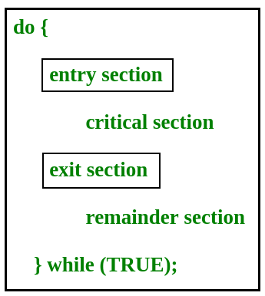
Critical Section Problem
- Critical section is a code segment that can be accessed by only one process at a time.
- Critical section contains shared variables which need to be synchronized to maintain consistency of data variables.
- In simple terms a critical section is group of instructions/statements or region of code that need to be executed atomically , such as accessing a resource (file, input or output port, global data, etc.).
- In concurrent programming, if one thread tries to change the value of shared data at the same time as another thread tries to read the value (i.e. data race across threads), the result is unpredictable.
- The access to such shared variable (shared memory, shared files, shared port, etc…) to be synchronized.
- Few programming languages have built-in support for synchronization.
- It is critical to understand the importance of race condition while writing kernel mode programming (a device driver, kernel thread, etc.). since the programmer can directly access and modifying kernel data structures.

A simple solution to the critical section can be thought as shown below,
acquireLock();
Process Critical Section
releaseLock();
A thread must acquire a lock prior to executing a critical section. The lock can be acquired by only one thread. There are various ways to implement locks in the above pseudo code.

In the entry section, the process requests for entry in the Critical Section.
Any solution to the critical section problem must satisfy three requirements:
- Mutual Exclusion: If a process is executing in its critical section, then no other process is allowed to execute in the critical section.
- Progress: If no process is executing in the critical section and other processes are waiting outside the critical section, then only those processes that are not executing in their remainder section can participate in deciding which will enter in the critical section next, and the selection can not be postponed indefinitely.
- Bounded Waiting: A bound must exist on the number of times that other processes are allowed to enter their critical sections after a process has made a request to enter its critical section and before that request is granted.
This setup can be defined in various regions like:
- Entry Section –
It is part of the process which decide the entry of a particular process in the Critical Section, out of many other processes.
- Critical Section –
It is the part in which only one process is allowed to enter and modify the shared variable.This part of the process ensures that only no other process can access the resource of shared data.
- Exit Section –
This process allows the other process that are waiting in the Entry Section, to enter into the Critical Sections. It checks that a process that after a process has finished execution in Critical Section can be removed through this Exit Section.
- Remainder Section –
The other parts of the Code other than Entry Section, Critical Section and Exit Section are known as Remainder Section.
SOLUTIONS FOR CRITICAL SECTION PROBLEM : -
- Software Approach –
In Software Approach, Some specific Algorithm approach is used to maintain synchronization of the data. Like in Approach One or Approach Two, for a number of two process, a temporary variable like (turn) or boolean variable (flag) value is used to store the data. When the condition is True then the process in waiting State, known as Busy Waiting State. This does not satisfy all the Critical Section requirements.
Another Software approach known as Peterson’s Solution is best for Synchronization. It uses two variables in the Entry Section so as to maintain consistency, like Flag (boolean variable) and Turn variable(storing the process states). It satisfy all the three Critical Section requirements.
//Image of Peterson’s Algorithm

Peterson’s Solution
Peterson’s Solution is a classical software based solution to the critical section problem.
In Peterson’s solution, we have two shared variables:
- boolean flag[i] :Initialized to FALSE, initially no one is interested in entering the critical section
- int turn : The process whose turn is to enter the critical section.
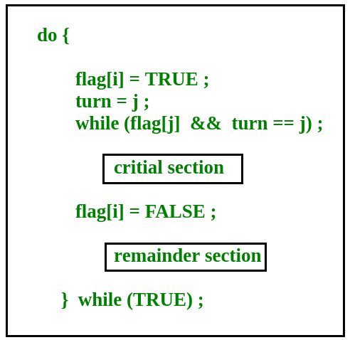
Peterson’s Solution preserves all three conditions :
- Mutual Exclusion is assured as only one process can access the critical section at any time.
- Progress is also assured, as a process outside the critical section does not block other processes from entering the critical section.
- Bounded Waiting is preserved as every process gets a fair chance.
Disadvantages of Peterson’s Solution
  - It involves Busy waiting
  - It is limited to 2 processes.
2.Hardware Approach –
The Hardware Approach of synchronization can be done through Lock & Unlock technique.
Locking part is done in the Entry Section, so that only one process is allowed to enter into the Critical Section, after it complete its execution, the process is moved to the Exit Section, where Unlock Operation is done so that another process in the Lock Section can repeat this process of Execution.
This process is designed in such a way that all the three conditions of the Critical Sections are satisfied.
//Image of Lock

Using Interrupts –
These are easy to implement.When Interrupt are disabled then no other process is allowed to perform Context Switch operation that would allow only one process to enter into the Critical State.
//Image of Interrupts
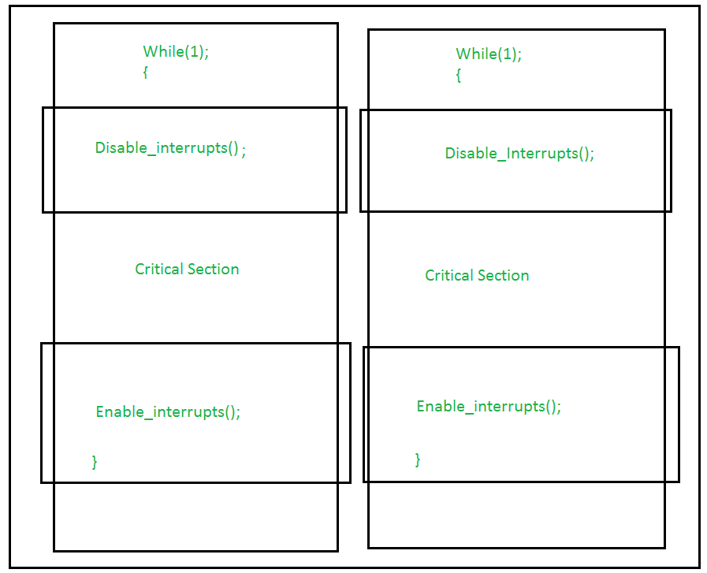

- TestAndSet
TestAndSet is a hardware solution to the synchronization problem. In TestAndSet, we have a shared lock variable which can take either of the two values, 0 or 1.
0 Unlock
1 Lock
Before entering into the critical section, a process inquires about the lock. If it is locked, it keeps on waiting until it becomes free and if it is not locked, it takes the lock and executes the critical section.
- In TestAndSet, Mutual exclusion and progress are preserved but bounded waiting cannot be preserved.
Question :The enter_CS() and leave_CS() functions to implement critical section of a process are realized using test-and-set instruction as follows:
int TestAndSet(int &lock) {
int initial = lock;
lock = 1;
return initial;
}

void enter_CS(X)
{
while test-and-set(X) ;
}

void leave_CS(X)
{
X = 0;
}
In the above solution, X is a memory location associated with the CS and is initialized to 0. Now, consider the following statements:
I. The above solution to CS problem is deadlock-free
II. The solution is starvation free.
III. The processes enter CS in FIFO order.
IV. More than one process can enter CS at the same time.
Which of the above statements is TRUE?
(A) I
(B) II and III
(C) II and IV
(D) IV
Click here for the Solution.
True
3.Semaphores
- A semaphore is a signaling mechanism and a thread that is waiting on a semaphore can be signaled by another thread. This is different than a mutex as the mutex can be signaled only by the thread that called the wait function.
A semaphore uses two atomic operations, wait and signal for process synchronization.
A Semaphore is an integer variable, which can be accessed only through two operations wait() and signal().
There are two types of semaphores: Binary Semaphores and Counting Semaphores
  - Binary Semaphores: They can only be either 0 or 1. They are also known as mutex locks, as the locks can provide mutual exclusion.
  - All the processes can share the same mutex semaphore that is initialized to 1. Then, a process has to wait until the lock becomes 0.
  - Then, the process can make the mutex semaphore 1 and start its critical section.
  - When it completes its critical section, it can reset the value of mutex semaphore to 0 and some other process can enter its critical section.
  - Counting Semaphores:
  - They can have any value and are not restricted over a certain domain.
  - They can be used to control access to a resource that has a limitation on the number of simultaneous accesses.
  - The semaphore can be initialized to the number of instances of the resource.
  - Whenever a process wants to use that resource, it checks if the number of remaining instances is more than zero, i.e., the process has an instance available. Then, the process can enter its critical section thereby decreasing the value of the counting semaphore by 1. After the process is over with the use of the instance of the resource, it can leave the critical section thereby adding 1 to the number of available instances of the resource.

IPC INTER PROCESS COMMMUNICATION:-
  - Inter-process communication (IPC) is a mechanism that allows processes to communicate with each other and synchronize their actions.
  - The communication between these processes can be seen as a method of co-operation between them.
  - Processes can communicate with each other through both:
- Shared Memory
- Message passing
Figure 1 below shows a basic structure of communication between processes via the shared memory method and via the message passing method.
- An operating system can implement both methods of communication.
- First, we will discuss the shared memory methods of communication and then message passing.
- Communication between processes using shared memory requires processes to share some variable, and it completely depends on how the programmer will implement it.
- One way of communication using shared memory can be imagined like this:
- Suppose process1 and process2 are executing simultaneously, and they share some resources or use some information from another process.
- Process1 generates information about certain computations or resources being used and keeps it as a record in shared memory.
- When process2 needs to use the shared information, it will check in the record stored in shared memory and take note of the information generated by process1 and act accordingly.
- Processes can use shared memory for extracting information as a record from another process as well as for delivering any specific information to other processes.
Let’s discuss an example of communication between processes using the shared memory method.
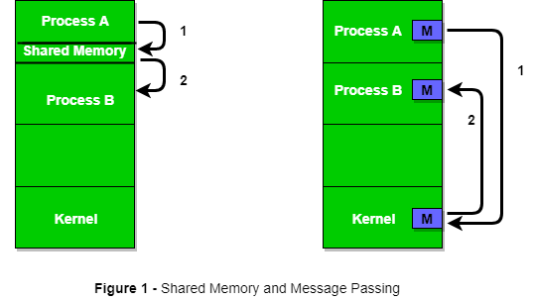

i) Shared Memory Method

Ex: Producer-Consumer problem
- There are two processes: Producer and Consumer.
- The producer produces some items and the Consumer consumes that item.
- The two processes share a common space or memory location known as a buffer where the item produced by the Producer is stored and from which the Consumer consumes the item if needed.
- There are two versions of this problem: the first one is known as the unbounded buffer problem in which the Producer can keep on producing items and there is no limit on the size of the buffer, the second one is known as the bounded buffer problem in which the Producer can produce up to a certain number of items before it starts waiting for Consumer to consume it.
- We will discuss the bounded buffer problem.
- First, the Producer and the Consumer will share some common memory, then the producer will start producing items.
- If the total produced item is equal to the size of the buffer, the producer will wait to get it consumed by the Consumer.
- Similarly, the consumer will first check for the availability of the item. If no item is available, the Consumer will wait for the Producer to produce it. If there are items available, Consumer will consume them.
- The pseudo-code to demonstrate is provided below:
Shared Data between the two Processes

#define buff_max 25
#define mod %

struct item{

// different member of the produced data
// or consumed data
---------
}

// An array is needed for holding the items.
// This is the shared place which will be
// access by both process
// item shared_buff [ buff_max ];

// Two variables which will keep track of
// the indexes of the items produced by producer
// and consumer The free index points to
// the next free index. The full index points to
// the first full index.
int free_index = 0;
int full_index = 0;

Producer Process Code
- C

item nextProduced;

while(1){

// check if there is no space
// for production.
// if so keep waiting.
while((free_index+1) mod buff_max == full_index);

shared_buff[free_index] = nextProduced;
free_index = (free_index + 1) mod buff_max;
}
Consumer Process Code
item nextConsumed;

while(1){

// check if there is an available
// item for consumption.
// if not keep on waiting for
// get them produced.
while((free_index == full_index);

nextConsumed = shared_buff[full_index];
full_index = (full_index + 1) mod buff_max;
}
In the above code, the Producer will start producing again when the (free_index+1) mod buff max will be free because if it it not free, this implies that there are still items that can be consumed by the Consumer so there is no need to produce more. Similarly, if free index and full index point to the same index, this implies that there are no items to consume.
ii) Messaging Passing Method
Now, We will start our discussion of the communication between processes via message passing.
In this method, processes communicate with each other without using any kind of shared memory. If two processes p1 and p2 want to communicate with each other, they proceed as follows:

- Establish a communication link (if a link already exists, no need to establish it again.)
- Start exchanging messages using basic primitives.
We need at least two primitives:
–send(message, destination) or send(message)
–receive(message, host) or receive(message)

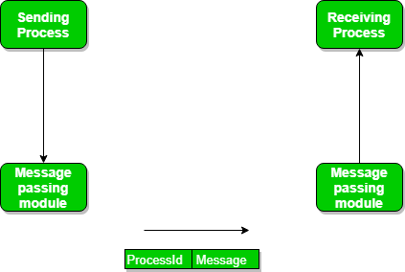
- The message size can be of fixed size or of variable size.
- If it is of fixed size, it is easy for an OS designer but complicated for a programmer and if it is of variable size then it is easy for a programmer but complicated for the OS designer.
- A standard message can have two parts:header and body.
- The header part is used for storing message type, destination id, source id, message length, and control information.
- The control information contains information like what to do if runs out of buffer space, sequence number, priority. Generally, message is sent using FIFO style.
Message Passing through Communication Link.
Direct and Indirect Communication link
Now, We will start our discussion about the methods of implementing communication links. While implementing the link, there are some questions that need to be kept in mind like :
- How are links established?
- Can a link be associated with more than two processes?
- How many links can there be between every pair of communicating processes?
- What is the capacity of a link? Is the size of a message that the link can accommodate fixed or variable?
- Is a link unidirectional or bi-directional?
- A link has some capacity that determines the number of messages that can reside in it temporarily for which every link has a queue associated with it which can be of zero capacity, bounded capacity, or unbounded capacity.
- In zero capacity, the sender waits until the receiver informs the sender that it has received the message.
- In non-zero capacity cases, a process does not know whether a message has been received or not after the send operation. For this, the sender must communicate with the receiver explicitly. Implementation of the link depends on the situation, it can be either a direct communication link or an in-directed communication link.
- Direct Communication links are implemented when the processes use a specific process identifier for the communication, but it is hard to identify the sender ahead of time.
For example the print server.
In-direct Communication is done via a shared mailbox (port), which consists of a queue of messages. The sender keeps the message in mailbox and the receiver picks them up.
Message Passing through Exchanging the Messages.
- Synchronous and Asynchronous Message Passing:
- A process that is blocked is one that is waiting for some event, such as a resource becoming available or the completion of an I/O operation.
- IPC is possible between the processes on same computer as well as on the processes running on different computer i.e. in networked/distributed system.
- In both cases, the process may or may not be blocked while sending a message or attempting to receive a message so message passing may be blocking or non-blocking.
- Blocking is considered synchronous and blocking send means the sender will be blocked until the message is received by receiver.
- Similarly, blocking receive has the receiver block until a message is available.
- Non-blocking is considered asynchronous and Non-blocking send has the sender sends the message and continue. Similarly, Non-blocking receive has the receiver receive a valid message or null.
- After a careful analysis, we can come to a conclusion that for a sender it is more natural to be non-blocking after message passing as there may be a need to send the message to different processes. However, the sender expects acknowledgment from the receiver in case the send fails. Similarly, it is more natural for a receiver to be blocking after issuing the receive as the information from the received message may be used for further execution. At the same time, if the message send keep on failing, the receiver will have to wait indefinitely. That is why we also consider the other possibility of message passing. There are basically three preferred combinations:
- Blocking send and blocking receive
- Non-blocking send and Non-blocking receive
- Non-blocking send and Blocking receive (Mostly used)
- In Direct message passing, The process which wants to communicate must explicitly name the recipient or sender of the communication.
- e.g. send(p1, message) means send the message to p1.
Similarly, receive(p2, message) means to receive the message from p2.
- In this method of communication, the communication link gets established automatically, which can be either unidirectional or bidirectional, but one link can be used between one pair of the sender and receiver and one pair of sender and receiver should not possess more than one pair of links.
- Symmetry and asymmetry between sending and receiving can also be implemented i.e. either both processes will name each other for sending and receiving the messages or only the sender will name the receiver for sending the message and there is no need for the receiver for naming the sender for receiving the message. The problem with this method of communication is that if the name of one process changes, this method will not work.
- In Indirect message passing,
- processes use mailboxes (also referred to as ports) for sending and receiving messages.
- Each mailbox has a unique id and processes can communicate only if they share a mailbox.
- Link established only if processes share a common mailbox and a single link can be associated with many processes.
- Each pair of processes can share several communication links and these links may be unidirectional or bi-directional.
- Suppose two processes want to communicate through Indirect message passing, the required operations are: create a mailbox, use this mailbox for sending and receiving messages, then destroy the mailbox.
- The standard primitives used are:send(A, message) which means send the message to mailbox A.
- The primitive for the receiving the message also works in the same way e.g. received (A, message).
- There is a problem with this mailbox implementation. Suppose there are more than two processes sharing the same mailbox and suppose the process p1 sends a message to the mailbox, which process will be the receiver?
- This can be solved by either enforcing that only two processes can share a single mailbox or enforcing that only one process is allowed to execute the receive at a given time or select any process randomly and notify the sender about the receiver.
- A mailbox can be made private to a single sender/receiver pair and can also be shared between multiple sender/receiver pairs.
- Port is an implementation of such mailbox that can have multiple senders and a single receiver. It is used in client/server applications (in this case the server is the receiver).
- The port is owned by the receiving process and created by OS on the request of the receiver process and can be destroyed either on request of the same receiver processor when the receiver terminates itself. Enforcing that only one process is allowed to execute the receive can be done using the concept of mutual exclusion. Mutex mailbox is created which is shared by n process. The sender is non-blocking and sends the message. The first process which executes the receive will enter in the critical section and all other processes will be blocking and will wait.
Now, let’s discuss the Producer-Consumer problem using the message passing concept. The producer places items (inside messages) in the mailbox and the consumer can consume an item when at least one message present in the mailbox. The code is given below:
Producer Code
- C

void Producer(void){

int item;
Message m;

while(1){

receive(Consumer, &m);
item = produce();
build_message(&m , item ) ;
send(Consumer, &m);
}
}
Consumer Code
- C

void Consumer(void){

int item;
Message m;

while(1){

receive(Producer, &m);
item = extracted_item();
send(Producer, &m);
consume_item(item);
}
}
Examples of IPC systems
- Posix : uses shared memory method.
- Mach : uses message passing
- Windows XP : uses message passing using local procedural calls
Communication in client/server Architecture:
There are various mechanism:
- Pipe
- Socket
- Remote Procedural calls (RPCs)

